Lumigrey reflective screens: clear results on baby-leaf, raspberry and tomatoes
A screen that combines an easy shading function with a temperature control ability underneath greenhouse: an essential feature, especially during hottest months.
These are just some characteristics of Lumigrey® reflective screens, a brand-new innovative technology for horticulture proposed by Agrintech from Eboli (Salerno) as an alternative to traditional shading nets.
A particular added value is due to an unique reflective foil that avoid high heat entering the structure.
Thanks to rachel weaving use, Lumigrey® is available from 30% up to 80% shading effect, giving an even wider range of possible applications.
On baby-leaf, spinach and baby spinach, Lumigrey® 40% and 50% already replaced the shading paint “technic” on covering plastic films, giving a more suitable microclimate inside greenhouse and right light condition useful for crops quality developing. That is why growing leaves stress is a far memory for growers.
Valerian has a high sensitivity with temperature over 35°C, particularly in presence of high luminosity or direct light hitting small leaves. To have plants with an uniform growth, strong, bright green colored and without chromatic alterations, it is necessary to have the right balance between shade, temperature and diffused light. According to what before, it is Lumigrey® 80 to give best result, thanks to its thicker and stronger mesh that limits UV entrance to the minimum, diminishing temperature and light intensity inside greenhouse.
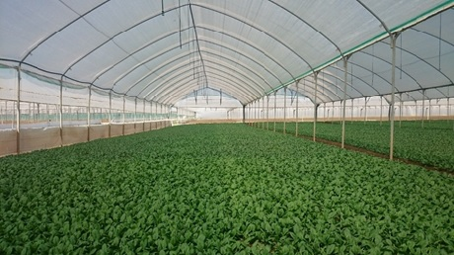
Lumigrey® 50 upon baby spinach. Clear uniform and luxuriant growth

Tomatoes grown inside greenhouse (datterino and ciliegino varieties first of all) seem to have found the right synergy with Lumigrey® 30%.
Advantages due to its application are various as many growers confirm every day:
- Net application from april to the end of september, with a financial return starting from the very first year (however, Lumigrey® market price is in the same range of standard shading nets).
- Uniform colored fruits, with no burn damage
- Less water, chemical and fertilizer cost thanks to less irrigation loops.
- Less virus attack (lo schermo permette di non alzare le fasce laterali di anti afide)
- Better conditions for workers inside greenhouse, with an increasing of workig hours even during hottest season.

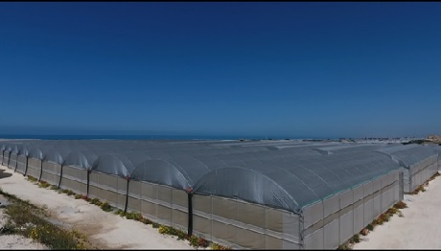
View of Lumigrey® 30 application on tomatoes greenhouses in Vittoria (Rg)
Small fruits production inside greenhouse in South Italy, for instance, is exposed to hard climatic condition due to dry and hot summer seasons.
Raspberry, in particular, suffers from those unusual conditions and growers have to content themselves with harvest poor in quality and quantity.
Lumigrey®, with a 40% shading percentage, can create undergrowth conditions, reproducing a cool temperature, ideal for palnt growth and developing also during hottest months.
Growers who uses Lumigrey® 40 already could verify the increasing plant strength right starting from the first year of application. To avoid stress set plant to more luxuriant and higher quality production.
The screen is applied over covering plastic film, thanks to its handy bracing strip all around its perimeter, and it is left on for all summer period giving advantage to both goods production and plastic film durability protected from UV and extended thanks to the net itself.
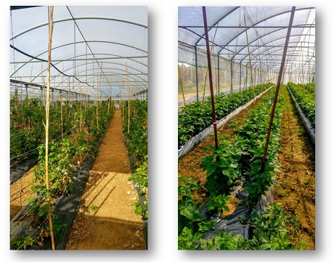
Raspberry comparison. On left, tunnel covered only with plastic film. On right tunnel covered with plastic and Lumigrey®
Lumigrey® is suitable for all kind of crops; thanks to its various shanding percentage It avoids stress in every step of plant growth.
Surelly, a more professional solution than old “shading paint” use but also an innovative solution with the ambitious aim to replace old standard net in the shading net market.
Agrintech staff is at your disposal to provide technical and commercial assistance.
For further information:
Agrintech srl
Tel.: (+39) 0828 332978
Fax: (+39) 0828 361955
Email: info@agrintech.it
Web: www.agrintech.it

